**PDF Implementation**

Contents

* Configuration
* Downloading Process
* Reading PDF’s
* Verification Process
* Configuration with the Maven Project

1. We configured below Tools to read PDF. Either we Can use PDFBOX or ITEXTPDF
2. PDFBOX maven repository.

<!-- https://mvnrepository.com/artifact/org.apache.pdfbox/pdfbox -->

<dependency>

<groupId>org.apache.pdfbox</groupId>

<artifactId>pdfbox</artifactId>

<version>2.0.21</version>

</dependency>

Include above repository in pom.xml of the project

1. ITEXTPDF maven repository.

<!-- https://mvnrepository.com/artifact/com.itextpdf/itextpdf -->

<dependency>

<groupId>com.itextpdf</groupId>

<artifactId>itextpdf</artifactId>

<version>5.5.13.2</version>

</dependency>

Include above repository in pom.xml of the project.

**Scripting Procedure (Example)**

String pdfContent;

records.switchToReportStatus();

records.reportStatus.downloadReport();

records.reportStatus.sendDownloadedFiletoServer("TestCaseID");

pdfContent = records.reportStatus.readPDFContent("TestCaseID(ie 205026)");

records.reportStatus.verifyAtAddress(pdfContent);

records.reportStatus.verifyAtCaseNo(pdfContent);

records.reportStatus.verifyAtCallNo(pdfContent);

* Downloading Process

1.We are downloading reports using Download function

**public** **void** downloadReport() {

objectIdentification.readPDF.DownloadReportsFromReportStatusScreen();

}

DownloadReportsFromReportStatusScreen();

Function will work for both IE and Chrome browsers.

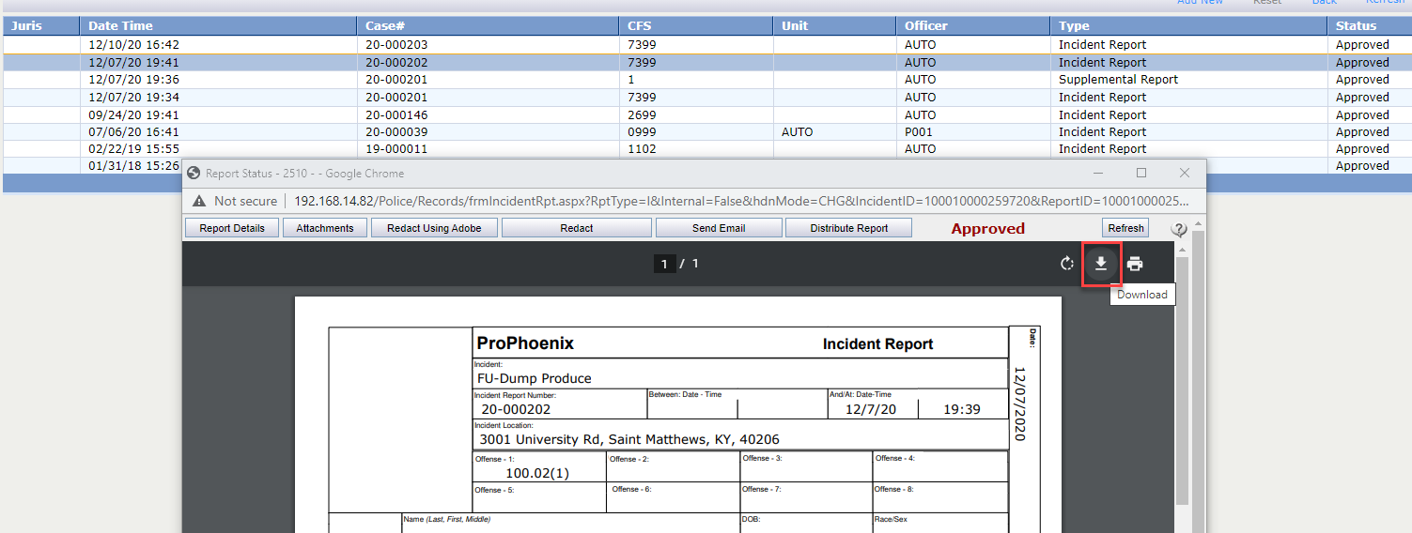

File will Download to Local Machine with random Name.

2. Local downloaded File we are sending to server path with the Name of Test Case ID or Report Name.

records.reportStatus.sendDownloadedFiletoServer("TestCaseID")

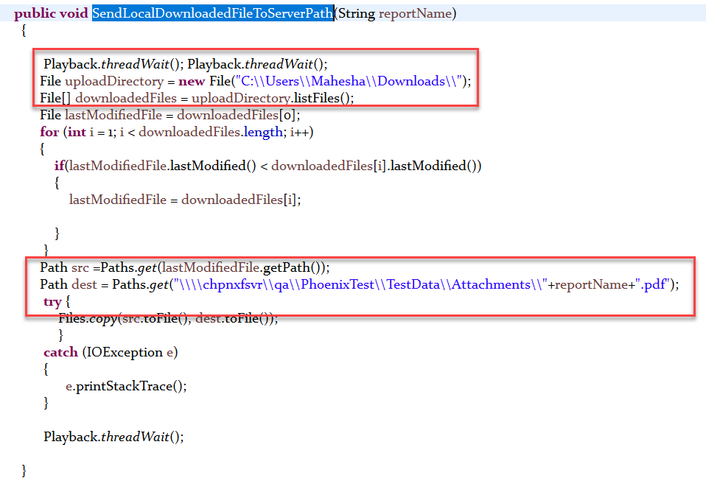

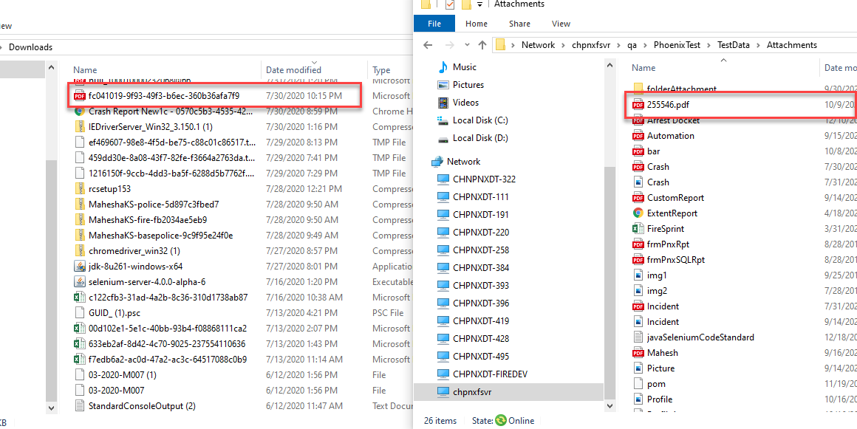

* Reading PDF’s

pdfContent = records.reportStatus.readPDFContent("TestCaseID(ie 205026)");

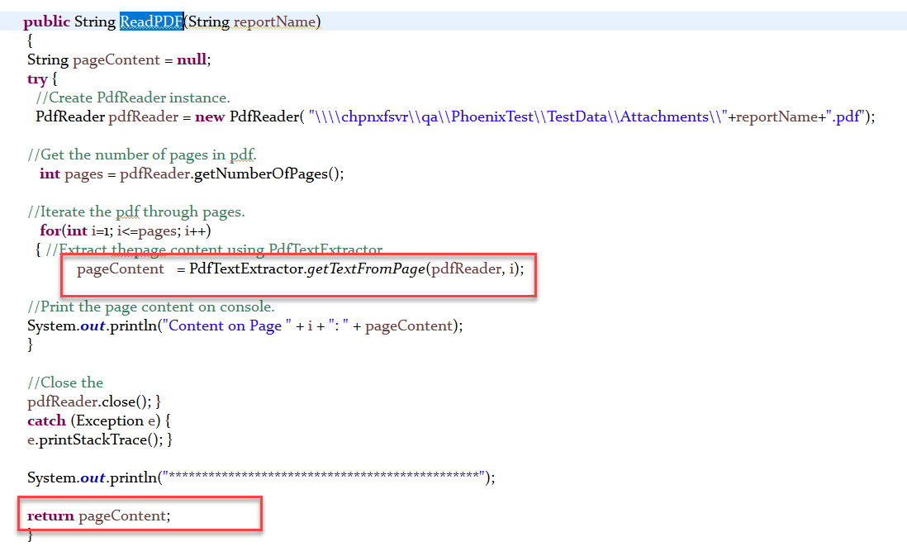

From server path we are passing the File name of the PDF, above function will read and return all the pages text content and we are storing that text in string variable.

Note – 1.For Above function we used itextpdf tool.

2.We are Included All the above Functions In ObjectIdentification class as Nested class - Named ReadPDF.

* Verification Process

records.reportStatus.verifyAtAddress(pdfContent);

records.reportStatus.verifyAtCaseNo(pdfContent);

records.reportStatus.verifyAtCallNo(pdfContent);

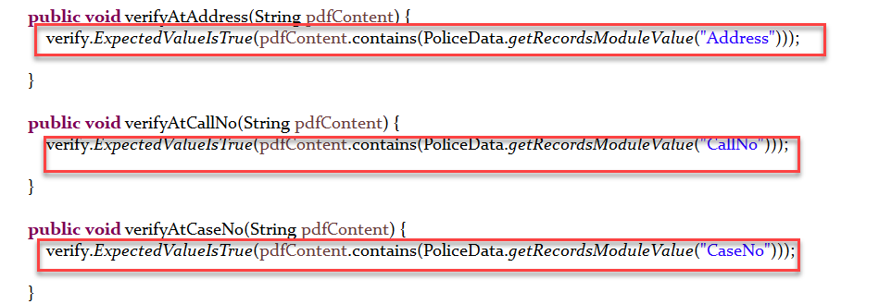

Finally, we are verifying PDF text content and Json data, to Validate the PDF reports.

**END**

Thank you

Mahesha K S